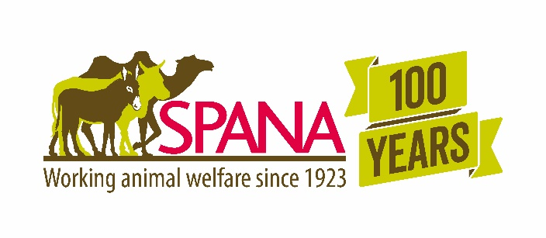

working animal welfare accelerator fund

Concept Note
INSTRUCTIONS: Please refer to SPANA’s Animal Welfare Accelerator Fund Guidance and Criteria before completing your application. The whole concept note should be 2-3 pages long. Instructions in red can be removed before submission.

Organisation Details
INSTRUCTIONS: Complete the following table with details of the organisation submitting the concept note.
Project Title
Organisation Name
Address
Website
Telephone
Fax
Contact Person | Name:  Telephone:  Mobile phone:  Email:
Registration Details | Type of organisation:  Country:  Year:  Registration Number:

Project Summary
INSTRUCTIONS: Insert a 1-2 paragraph summary of the project highlighting the target area, groups and animals, strategy and expected results. Write this section after you have completed all other sections of the concept note.
<Insert summary here>

Problem
<Briefly describe the problem being addressed>

Target Area & Target Groups
<Briefly describe the geographic target area and the animals and people who will benefit from the program>

Goal
<Insert the goal of the project>

Outcomes
- <Insert outcome 1>
- <Insert outcome 2>
- <Insert outcome 3>.
- <Add additional rows as needed>

Duration
<Describe when the project will start and finish>

Approach
<Briefly describe the overall approach that you will use to solve the problem. If the approach is something that has been used before then describe how it has been used previously and why you think it will be appropriate in your setting>

Monitoring & Evaluation
<Briefly describe how you will measure results. List the key indicators if appropriate>

Budget
<Give the total budget for the project>

Sustainability
<Briefly describe how the project activities will be sustained in the long term>

PLEASE SUBMIT YOUR APPLICATION TO globalprogrammes@spana.org BY THE 28TH OF JULY.

